**Focus Keyword: Bloom Greens and Superfoods**

**Meta Title: Bloom Greens and Superfoods | Educatecast**

**Meta Description:** Bloom Greens & Superfoods powder is a fine green powder that is intended to complement your existing consumption of greens and Superfoods.

**Feature Image:**

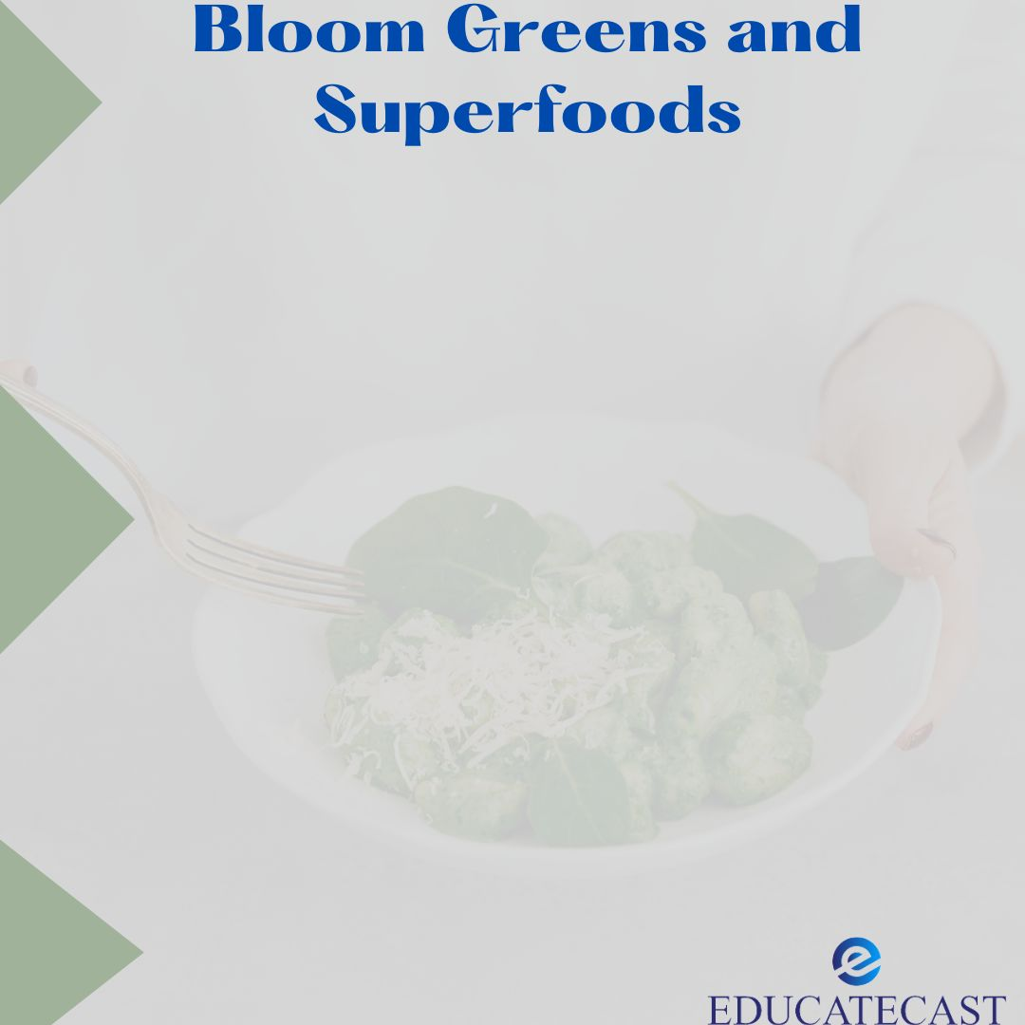

**Bloom Greens and Superfoods**

Bloom Greens aaaaand Superfoods powder is a fine green powder that is intended to complement or add to your existing consumption of greens and "Superfoods" (foods that are naturally rich with important nutrients) such as berries or broccoli.

**Bloom Greens and Superfoods Development**

Mari Llewellyn and Greg LaVecchia, a married couple, developed Bloom Nutrition in 2019. According to Bloom's website, Llewellyn saw a need in the supplement business for "health supplements with high-quality ingredients that tasted wonderful" as a newcomer to the fitness scene.

According to Llewellyn, the Greens and Superfoods powder is the company's top selling and has gone viral on Tiktok. Bloom Nutrition also sells collagen, pre-workout supplements, protein, and vitamins. Bloom items are available at Target stores and online nationwide.

**What Exactly Are Greens Powders?**

Greens powders are nutritional supplements that may be mixed with water or other liquids. They are generally green in colour and have a grassy flavour. Natural sugar alternatives are frequently used to enhance flavour.

Greens powders often contain 25-40 or more different components, which vary depending on the brand. These are frequently:

• **Probiotics:** Lactobacillus (L.) rhamnosus, Lactobacillus acidophilus, Bifidobacterium lactis

• **Plant-based digestive enzymes**: Amylase, cellulase, lipase, papain, protease

• Herbs include holy basil, astragalus, Echinacea, and milk thistle.

• **Mushrooms**: Maitake mushroom extract, Shiitake mushroom extract

• **Natural sugar substitutes**: Stevia leaf extract, monk fruit extract

• **Leafy greens** (spinach, kale, collards, and parsley)

• **Seaweed** (spirulina, chlorella, dulse, and kelp)

• Additional veggies include broccoli, beets, carrots, tomatoes, and green cabbage.

• **Grasses:** barley grass, wheatgrass, oat grass, alfalfa grass;

• A**ntioxidant-rich fruits**: blueberries, raspberries, goji berries, and acai berries

• Green tea extract, grape seed extract, ginkgo biloba extract

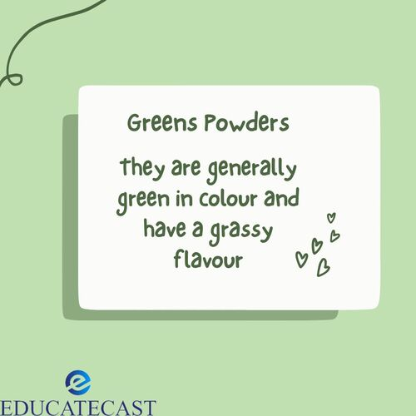

In most cases, the food utilized in these supplements is dried and then pulverized into powder. Alternatively, some items may be juiced and then dehydrated, or specific components of the complete dish could be removed.

**Sprouting or fermenting foods** is a newer trend that boosts vitamin levels and helps break down chemicals that might interfere with mineral absorption.

The formulas are frequently vegan, non-genetically modified, and organic — but check the product label for further information.

**Price of Bloom Greens and Superfoods**

Greens powder prices range from 22 cents to 99 cents or more per scoop (approximately 10 grams or two tablespoons), depending on the contents. A 30-serving bottle of Greens & Superfoods powder in any flavour costs $39.99. A container containing 60 servings costs $79.99.

Bloom's website has a "**Subscribe & Save"** option where you may choose to get the product every 30, 60, or 90 days and earn a 10% discount. This subscription plan can be changed, stopped, or terminated at any time.

Bloom further promises that by subscribing to these frequent deliveries, you would have access to unique bargains, unexpected gifts, and assured delivery during times of low inventory. For orders of $50 or more in the United States, shipping is free.

**Bloom Greens and Superfoods Solution**

Bloom Greens and Superfoods powder includes 15 calories, 3 grams of carbohydrates, 2 grams of dietary fiber, 0.6 milligrams of iron, and 5 milligrams of sodium per serving (or scoop). There is additionally 57 milligrams of stevia leaf extract to sweeten the product.

The label also categorizes its hundreds of constituents as **fiber, green Superfood, pre and probiotic, fruit and vegetable, antioxidant beauty, digestive enzyme, and adapt genic blends**.

**The powder is available in five flavours:**

* BERRY
* COCONUT
* CITRUS
* ORIGINAL
* MANGO

**The Small Print**

Bloom Greens and Superfoods promises to help with digestion, bloating, and immunity on the front label, but admits on the back that these claims have not been tested by the FDA.

The product is made in a **cGMP (Certified Good Manufacturing Practices)** facility that must adhere to **FDA requirements**. According to Bloom's FAQ website, the plant also processes nuts and dairy products.

**Packaging of Bloom Greens and Superfoods**

The product comes in a plastic tub with a largely green label and one plastic scoop inside for accurate measuring of each serving. One scoop of the Original flavour weighs 5.05 grams and serves one. Bloom recommends one to two servings daily. One scoop of the greens powder should be mixed with 8 to 12 fluid ounces of water or your favourite drink using a high-powered mixer.

According to the packaging, Bloom's Greens and Superfoods powder is plant-based and devoid of soy, gluten, dairy, and GMO ingredients.

**Pros**

* Manufactured in a cGMP (Certified Good Manufacturing Practices) facility
* Sweet flavor
* Comes with a serving scoop

**Cons:**

* There is no third-party testing of the contents;
* The amount of components may be insufficient to give much of a health advantage;
* The health benefit claims are not authorized by the US Food and Drug Administration (FDA)

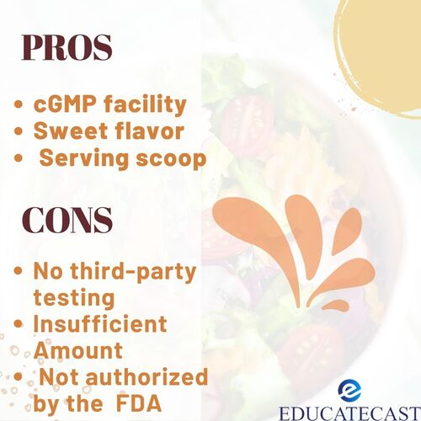

**The Customer Experience**

**Here are customer reviews;**

Bloom Nutrition positions itself as a fun and modern supplement company, making it simple to believe in its products and promises. I was very excited about the benefits of reduced bloating and improved digestion.

I used the Greens and Superfoods powder in Original taste every day for a week, mixing it with water and in a smoothie (with frozen berries, carrot juice and a protein powder). The label suggests whisking the powder into the liquid with a high-powered mixer, which works, but shaking with a blender ball works just as well with water.

On Amazon, the product has a 4.5-star rating based on over 20,000 global ratings, with 75% of those being 5-star evaluations.

**Expert Point about Bloom Greens and Superfoods**

While the amount of each ingredient may not be sufficient to provide therapeutic (i.e. truly healing) effects, the combination of ingredients "may provide some antioxidants, adaptogens, enzymes, and prebiotic fiber," according to **Nichole Dandrea-Russert, M.S.,** registered dietitian nutritionist and author of The **Fiber Effect.**

**Jaclyn London**, a registered dietitian and licensed dietician-nutritionist in New York, hopes that buyers would exercise caution before purchasing Bloom Nutrition products. "The main difficulty from a nutrition sense is that because it's supposedly produce [fruits and vegetables] in powdered form, you're obviously losing fiber, antioxidants, water, and critical mineral advantages that you would otherwise receive if you ate a full food in any form," she explains.

Both Dandrea-Russert and London emphasize that the powder should be taken as a complement to a balanced diet, not as a replacement for complete meals.

**Bloom Greens and Superfoods FAQs**

1. **What is the purpose of Bloom Nutrition?**

This probiotic blend regulates your stomach, eliminates gas, and detoxifies your digestive tract. A scoop of Greens dietary supplement relieves bloating and reduces intestinal inflammation rapidly.

1. **Is Bloom nutrition greens a probiotic?**

Bloom Nutrition Green Superfood | Super Greens Powder Juice & Smoothie Mix | Complete Whole Foods (Organic Spirulina, Chlorella, Wheat Grass), Probiotics, Digestive Enzymes, & Antioxidants (Berry)

1. **When is the best time to consume flowering greens?**

With or without food? We created our Greens product to include everything you need for the most nutrition, so you don't need to take it at a specific time of day or with or without meals. Everything you need for the dish is right there in the scoop, so take whenever is convenient for you.

1. **What are the benefits of greens and Superfoods?**

They're high in vitamins, minerals, and fiber while being low in calories. A diet heavy in leafy greens has been shown to lessen the risk of obesity, heart disease, high blood pressure, and mental decline.

1. **What are the advantages of super greens powder?**

* They are high in vitamins and minerals.
* Greens are abundant in cancer-fighting antioxidants.
* Many plant-based diets lessen inflammation.
* The dietary fiber in greens aids digestion.